**Project Design Phase-I**

**Solution Architecture**

|  |  |
| --- | --- |
| Date | 18 October 2022 |
| Team ID | PNT2022TMID23778 |
| Project Name | Project – Sings With Smart Connectivity For Better Road Safety |
| Maximum Marks | 4 Marks |

**Solution Architecture Diagram:**

The weather and temperature details are obtained from the OpenWeatherMap API. Using these details, the speed limit will be updated automatically in accordance with the weather conditions. Also, the details regarding any accidents and traffic congestion faced on the particular road are obtained Based on this, the traffic is diverted followed by a change in map path and the traffic is cleared.

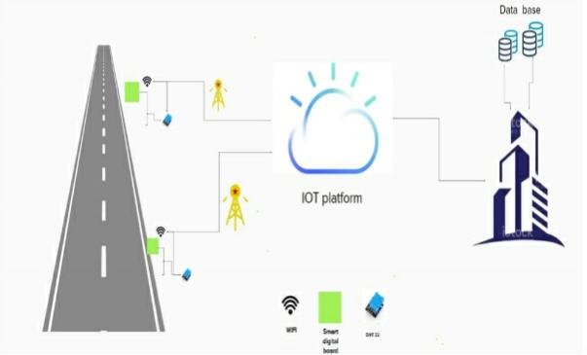

Figure 1: Architecture and data flow of the Open Weather Map sample application